Computer Language Coding Concepts

Execution Class Redirection in a Diagram
Execution class redirection is explained in the article Execution Class Redirection. The current article demonstrates the concept in a diagram.

The picture below displays a command call, redirecting its definition to an inactive command.

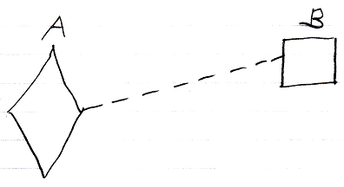

Active command symbol A is a diamond shape, because it is an active command. Active command symbol A redirects its definition to the inactive command symbol B. Symbol B is a square because it is an inactive command. The redirection from command A to command B is displayed as a dashed line, which is a class line. This makes symbol A a command call, for which command B functions as a definition. When command call A runs, it will take over the properties of command definition B, because command definition B functions as command A’s prototype. But command call A will have its own data, so it is an instance of command B, so command B only functions as its prototype, hence a class line is used, and not a solidly drawn object line, that would turn both symbols into the same instance.

The direction of the line does not need to be indicated in the diagram, because the direction is obvious. An execution can only redirect its target, but never function as the target of a redirection, so the direction of the redirection always goes from the execution to the definition, so an access mark does not have to be used to indicate the direction.

See also: Execution Class Redirection, Commands

Author & Copyright: Jan-Joost van Zon Date: August 10, 2008 – August 10, 2008 Location: Oosterhout, The Netherlands Status: Finished

